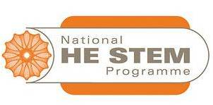
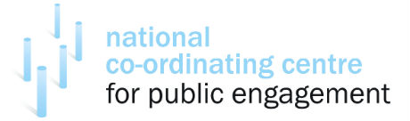

Beginners Guide to Evaluation -Wednesday 29th February

Aston Conference Centre

Introduction to the workshop
The NCCPE and the Beacons for Public Engagement have been commissioned by the National HE STEM Programme to support HE STEM practitioners developing their evaluation skills. A survey was launched to inform this development and based on the feedback this practical workshop has been created aimed at HEI staff and students who have experience of undertaking HE STEM outreach activities.

This interactive workshop aims to explore and develop:
- an understanding of the value and importance of evaluating HE STEM outreach.
- an understanding of the process of successful evaluation and collecting evidence of impact.
- the issues and challenges of evaluating HE STEM outreach.
- personal and professional skills, for example communication, planning and critical reflection.
- an increased confidence in developing an evaluation plan and using new, alternative approaches to evaluating public engagement.
- understanding on the uses of evaluation including improving activities; sharing good practice and reporting.

Programme outline
TIME | ACTIVITY
09:30 – 10.00 | Participant registration
10:00 – 11.00 | Networking and sharing
10:00 – 11.00 | Introduction to the programme
10:00 – 11.00 | Why evaluate your outreach activities?
10:00 – 11.00 | What are you aiming to do?  - Evaluation Plan  - Writing aims and SMART objectives
11:00 – 11:20 | Break
11:20 – 12.20 | What question do you want to ask?
11:20 – 12.20 | Devising your methodology
12:30 – 13:15 | Lunch
13:15 – 14:15 | Collecting your data
14:15 – 14:25 | Break
14.25 – 15:30 | Analysing your data
14.25 – 15:30 | Making use of your evaluation
15.30 -16.00 | Plenary

