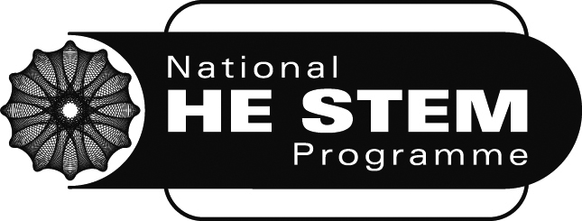
Final Case Study Report Template

IMPORTANT: The SW final report guidance document must be consulted before completing this report template. Please complete all sections.

Project Title:

Project Leader:

Department/School:

Institution:

Other institutions/organisations involved in the project:

Abstract:

List of Outputs:

Project Highlights:

1.

2.

3.

Background and Rationale:

Implementation:

Evaluation:

Discussion, Learning and Impact:

Further Development and Sustainability

Will the activity continue in the future?
(a) Yes (in its current form) (b) Yes (in a modified form) (c) No/Unsure

If you answered (a), how has this sustainability been achieved and in particular how have you enabled the activity to continue without HE STEM funding or direct support?

If you answered (b), how will the continuing activity differ, for example, in its structure or delivery? How will the activity be sustainable and continue as a result of this modification?

If you answered (c), what has prevented the activity from becoming sustainable? What will now happen to the activity?

If you answered ‘unsure’, upon what does sustainability depend?

In relation to the approaches to sustainability outlined below, we are very interested in activities and commitments which have occurred within the timescale of the project. However, we recognise that some approaches may still be in the development phase at the official project end date and it would also be valuable to include these examples in the template.
Approaches to Sustainability | Examples | In relation to your project
Continuance (finding alternative sources of funding) | Commitment from institutions to provide continuation funding  - Network/ communities likely to be sustained through inclusion in future funding bids
Embedding (within institutional activity) | - Identification of institutional strategies that the project has informed  - Uptake which has taken place, or is likely to take place, within own/other HEIs  - Influencing of organisations external to HE Sector which has occurred through partnership working
Mainstreaming (changes in working practices) | - Staff development which is planned or has taken place as a result of your project  - Curriculum enhancement that has occurred or is likely to take place as a result of your project  - Influence of senior managers that has arisen as a result of the project
Legacy (passing on important elements of the project) | - Networks/communities likely to be continued  - Dissemination of project outputs  - Evidence of impact of activities  - Creative Learning Journey material made available via the SW Spoke Creative STEM website where relevant.

References:

Quotes:

Many thanks!

Internal commentary
Discussion, Learning and Impact: Would you like to expand on any points made in your answer to the question outlined in the guidance document: If you think your work did not/is not having an impact, are there any lessons you have learnt or changes that you could make which you would like to tell us about?

Further Development & Sustainability: Would you like to expand on any points made in your answer to the question: If project outputs are unlikely to be sustainable in the future, either in their current form, a modified form, or through the sorts of mechanisms listed above, what has prevented this occurring?

Feedback to the SW Spoke:
We would be very grateful for your feedback on your experiences of being involved in the National HE STEM Programme. We are keen to understand what it has really been like for you, so please let us know about both the positive and negative aspects of your experiences. Please comment on:
- To what extent have the support mechanisms and management processes your project has received from the SW Spoke been effective and efficient?
- What experiences have you had of National HE STEM activity outside the SW region? To what extent have you felt a part of the full National HE STEM Programme? Do you feel that you have gained any additional benefits or opportunities through being a part of a National Programme, for example by forming new links with partners in other regions?
- Any other generic comments about your experience of being involved in the National HE STEM Programme.
If you would prefer to comment anonymously, you are welcome to use the following link: http://www.surveymonkey.com/s/VCVMMSZ

